Applicant Organization:
Project Title:

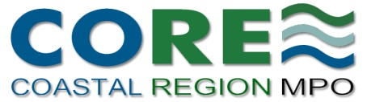

Coastal Region Metropolitan Planning Organization

Transportation Alternatives (TA)
Call for Projects

Application

December 2018

An electronic copy of the completed application is due:
January 15, 2019 by 5:00 p.m.

Send to:
Wykoda Wang, Transportation Administrator
Chatham County-Savannah Metropolitan Planning Commission
wangw@thempc.org

Phone:
912-651-1466

This page is intentionally left blank.

Coastal Region Metropolitan Planning Organization

Transportation Alternatives (TA)
December 2018 Call for Projects

CHECkList for Applicants

□ | Have you answered all applicable questions in the application?
□ | Has the appropriate person signed the application?
□ | Have you filled out the detailed budget table on the last page of this application?
□ | Have you attached a letter from your governing board or chief staff person who is able to commit to the local match?
□ | Have you attached a project location map?
□ | Have you attached other information that is applicable to the answers in your application?

This page is intentionally left blank.

Coastal Region Metropolitan Planning Organization (CORE MPO)

Transportation Alternatives (TA)
Application

December 2018 Call for Projects

The Coastal Region Metropolitan Planning Organization (CORE MPO) is conducting a competitive project selection process in order to award Transportation Alternatives (TA) funds.

- Minimum Award = $200,000 (federal portion, not total project cost)

- Maximum Award = $3,024,247 (federal portion, not total project cost)

- At least 20% of the eligible costs of the proposed project must be non-federal funds.
(Previously incurred costs cannot be counted as part of the 20% matching the newly awarded federal funds.)

The December 2018 Call for Projects targets to award Z301 funds from FY 2019 through FY 2021, to allow around $3 million of federal funding to be awarded in this round. The MPO may award one proposal or several. Therefore an applicant may request up to $3,024,247 for the federally funded portion of their proposal. Please be aware that the entire $3 million is not immediately available for programming in the initial years of the Transportation Improvement Program (TIP), and therefore project sponsors will need to be flexible about the project schedule if requesting more than $2 million. MPO staff will coordinate with the project sponsor regarding the TIP programming schedule for their project.

The federal funding request in this application can represent no more than 80% of the total cost of the applicant’s proposal. (Thus, for example, an applicant requesting $1,000,000 in federal TA funds, and providing no more than the required 20% local match, would be submitting a proposal totaling $1,250,000.)

- Federal requirements for the project development process are associated with federal funds.

Applicants should keep in mind that this federal funding involves adherence to several federal requirements, as applicable, such as the National Environmental Policy Act (NEPA), prevailing wage rates (Davis-Bacon), Buy America, competitive bidding, and other contracting requirements, regardless of whether the projects are located within the right-of-way of a Federal-aid highway. CORE MPO has set a minimum federal request in this round because the federal requirements tend to make larger projects more administratively efficient. For guidance about the treatment of projects with these federal funds, see the web page at: http://www.fhwa.dot.gov/environment/transportation_alternatives/guidance/guidance_2016.cfm#TreatmentProjects.

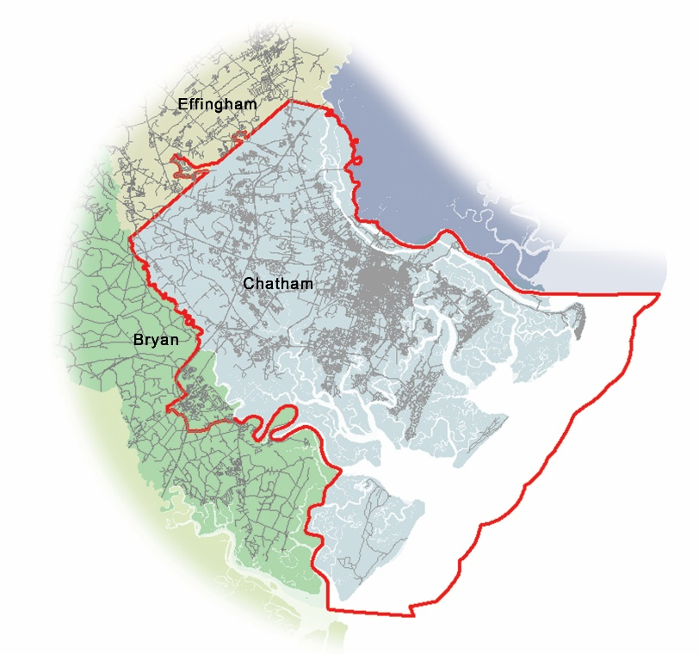
- Projects funded through this selection process must be located within the CORE MPO’s Metropolitan Planning Area (MPA) boundary.
The CORE MPO planning area is outlined in red.

The Metropolitan Planning Area includes all of Chatham County, as well as Richmond Hill in Bryan County and a small portion of unincorporated Effingham County (see map).

Transportation Alternatives funding is not subject to the prohibition against use on local roads or rural minor collectors, as generally applies to Surface Transportation Block Grant (STBG) funds. (Incidentally, TA-type projects are not subject to the prohibition even if funded with STBG funds.)

Please see CORE MPO Transportation Alternatives Manual for additional information.

Applicant and Project Information

Eligible Entities

Please indicate which type of eligible entity is the primary project sponsor: (Select one.)
□ | Local government
□ | Regional transportation authority
□ | Transit agency
□ | Natural resource agency or public land agency
□ | School district, local education agency, or school (public or nonprofit private)
□ | Tribal government
□ | Other local or regional governmental entity with responsibility for oversight of transportation or recreational trails that the State of Georgia determines to be eligible, consistent with the goals of subsection (c) of section 213 of title 23.
□ | Non-profit entities responsible for the administration of local transportation safety programs.

Types of Eligible Projects

Please indicate which categories your proposal falls under: (Select as many as apply. The number of categories does not affect your project’s score.)

□ | Construction, planning, and design of on-road or off-road trail facilities for pedestrians, bicyclists, or other nonmotorized forms of transportation, which can include sidewalks, bicycle infrastructure, pedestrian and bicycle signals, traffic calming techniques, lighting and other safety-related infrastructure, and transportation projects to achieve compliance with the Americans with Disabilities Act
□ | Construction, planning, and design of infrastructure-related projects and systems that will provide safe routes for non-drivers, including children, older adults, and individuals with disabilities to access daily needs
□ | Conversion and use of abandoned railroad corridors for trails for pedestrians, bicyclists, or other nonmotorized transportation users;
□ | Construction of turnouts, overlooks, and viewing areas;
□ | Community improvement activities, which can include but are not limited to: inventory control, or removal of outdoor advertising; historic preservation and rehabilitation of historic transportation facilities, vegetation management practices in transportation ROW, archeological activities relating to impacts of a transportation project eligible under Title 23 of the USC.
□ | Environmental mitigation activity, including stormwater management and water pollution prevention or abatement from highway construction or highway runoff; reduction of vehicle-cased wildlife death, restoration of the connectivity of habitat.
□ | Recreational trails under 23 USC 206.
□ | Safe Routes to School (SRTS) infrastructure-related project
□ | Safe Routes to School (SRTS) non-infrastructure-related project
□ | Planning, designing, or constructing boulevards and other roadways largely in the right-of-way of former Interstate System routes or other divided highways.

Applicant Information
Primary Sponsor Agency Name (i.e. agency that will manage implementation) |  | Date
Street Address | City, State | Zip Code
Contact Person’s Name | Title
Contact Person’s Phone Number | Contact Person’s Email Address
Project Manager’s Name (if awarded) | Title

Project Overview
Project Name

Project Location Description (please also attach a location map)

County (or counties) in which project is located |  | City (or cities), if any, in which project is located
Proposal Description Summary

Total Estimated Project Cost*  $ | Federal Funds Requested under TA  $ |  | Local Match  $
*Please also be sure to fill out the Budget Detail Table at the end of this application.

Who is providing the local match?

Name of Agency or Organization | Source (e.g. particular CIP fund)
Please attach a letter signed by either your governing board or an official or chief staff person who is able to commit to the stated local match.

Has the agency that will be managing this project previously completed other federal-aid transportation projects? (Choose one)
□ | 0 completed federal-aid projects
□ | 1 completed federal-aid project
□ | 2 completed federal-aid projects
□ | 3 or more completed federal-aid projects

Please list up to three federal-aid projects completed by your agency, if applicable, preferably for projects that are similar to your proposal:
P.I. No. | Project Name | Sponsor’s Project Manager

What agency will maintain the project after completion?
____________________________________________________________________________________

If a maintenance agreement is necessary, has it been executed? (Chose one) Y / N / NA
If yes, please attach the agreement.

If the completed project will generate the need for operational funds, please describe the estimated annual cost and the status and source of funding for operations. (TA funds will not cover operations.)

Will your project require purchase(s) or easement(s) for right-of-way (Choose one) Y / N / Maybe
Additional information:

If other agencies or organizations are partnering with you on this application or on implementation of your proposal, please list and describe the nature of assistance and the status of any agreements (e.g. ROW donations or easements):

Organization #1
Contact Name | Contact Phone
Contact Email:
Status of Agreement

Organization #2
Contact Name | Contact Phone
Contact Email:
Status of Agreement

Organization #3
Contact Name | Contact Phone
Contact Email:
Status of Agreement

If funding were available today, and you had already received a Notice to Proceed, how much time do you estimate would be needed for any phases of your project that would be funded by this request:

Phase(s) to be TA-funded | No. of Months

Please list any necessary preliminary work that already has been completed, and provide dates (e.g. GDOT concept approval, FHWA environmental approval or categorical exclusion, etc.):

Steps Completed | Date

Please describe status of any non-TA funded work that still needs to be completed before the project or phase that would be funded by this request can begin (e.g. if TA + Local Match will fund only the construction phase, what is the status and schedule for the incomplete preliminary engineering and ROW phases?).

Status of Steps to be carried out before TA-funded work begins | Estimated completion date

In 500 words or less, please describe what public benefits and efficiencies would be provided to our area by your proposed project. (In preparing your answer, we suggest you review the TA scoring criteria related to access, connectivity, tourism, and safety, as shown in CORE MPO’s Transportation Alternatives Manual – 2017.)

I understand that the latest versions of the following, as they relate to this project, shall guide project development and design.

- Accessible Public Rights-of-Way, Planning and Designing for Alterations, Public Rights-of-Way Access Advisory Committee.
- ADA Standards for Accessible Design, Department of Justice.
- Context Sensitive Design Manual, GDOT.
- Designing Walkable Urban Thoroughfares: A Context Sensitive Approach, Institute of Transportation Engineers (ITE) and Congress for the New Urbanism (CNU).
- A Policy on the Geometric Design of Highways and Streets, AASHTO.
- Guide for the Development of Bicycle Facilities, AASHTO.
- Guide for the Planning, Design, and Operation of Pedestrian Facilities, AASHTO.
- Manual on Uniform Traffic Control Devices (MUTCD), FHWA.
- Proposed Guidelines for Public Rights-of-Way (PROWAG)2, United States Access Board.
- Urban Bikeway Design Guide, NACTO.
- Urban Street Design Guidelines, NATCO.

SPONSOR

________________________________________ _____________________________________
Name Title

_____________________
Date

Please remember:

- To fill out the Detailed Budget Table, to the extent applicable, on the following page;
- To attach a letter from your governing board or other official or chief staff person who is able to commit the agency to the stated local match.
- To attach a Project Location Map;
- To attach an executed maintenance agreement if you indicated that one exists.

Budget Detail for Proposal
Project Name:
Activity | Desired Fiscal Year for TIP Programming (GDOT Fiscal Year) ¹ | Total Estimate | Requested CORE MPO TA Federal Funds (Maximum allowed is 80% of your total eligible costs.) | Local Match (Minimum required is 20% of your total eligible costs.) | Local Match Breakdown (by source)
 |  |  |  |  | Amount A | Source A | Amount B | Source B | Amount C | Source C
PE

ROW

Utilities

Construction

Other activity
Specify:
Other activity
Specify:
Other activity
Specify:
Total Amounts
Please use this area to explain whether other grants or sources (not already shown above) are dedicated either to the proposed phase or to future phases, of your project.

- The first GDOT fiscal year in the MPO’s TIP is FY 2018, which begins July 1, 2017. The last year of the next TIP is FY 2021, which begins July 1, 2020.

